**Java Interview Questions**

1. What's difference between LinkedList and ArrayList? Explain space and time complexity? What's the traversal mode of both the containers?

|  |  |
| --- | --- |
| LinkedList | ArrayList |
| Doubly-linked list implementation of the List and Deque interfaces. | Resizable-array implementation of the List interface |
| All of the operations perform as could be expected for a doubly-linked list. Operations that index into the list will traverse the list from the beginning or the end, whichever is closer to the specified index. | Implements all optional list operations, and permits all elements, including null. In addition to implementing the List interface, this class provides methods to manipulate the size of the array that is used internally to store the list |
| The size, isEmpty, get, set, iterator, and listIterator operations are O(n) | The size, isEmpty, get, set, iterator, and listIterator operations run in constant time |
| Adding element at the end or beginning is O (1). | The add operation runs in *amortized constant time*, that is, adding n elements requires O(n) time. All of the other operations run in linear time (roughly speaking). |

1. Difference between Checked and Unchecked Exception

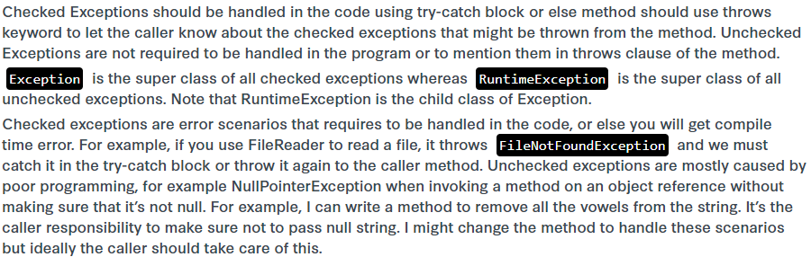

1. How do you serialize an object?

By implementing Serializable

To make any field not to serialize, mark the field transient.

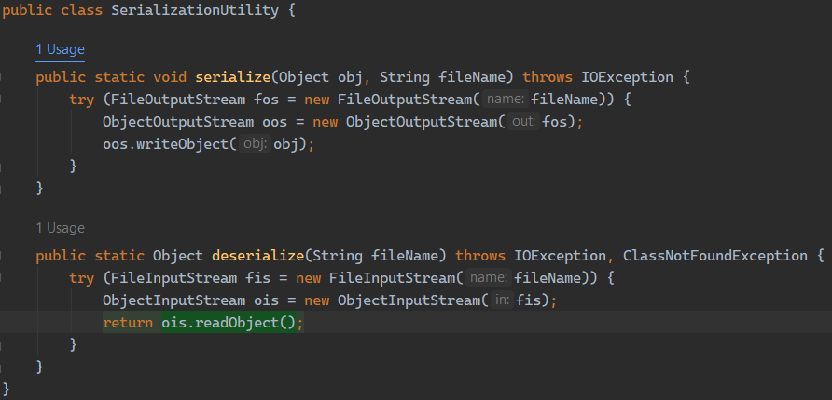

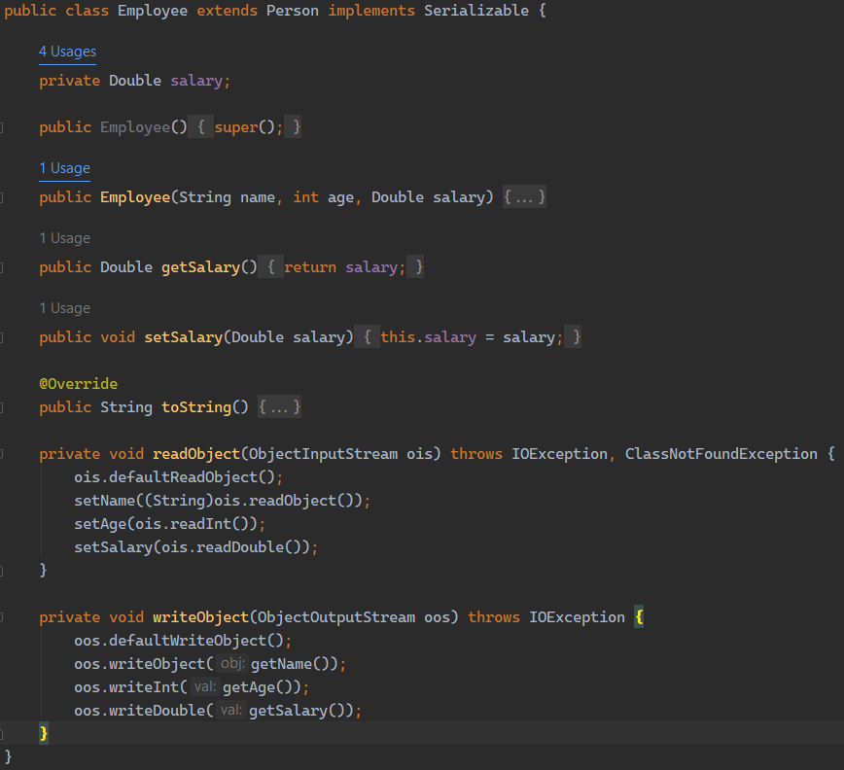

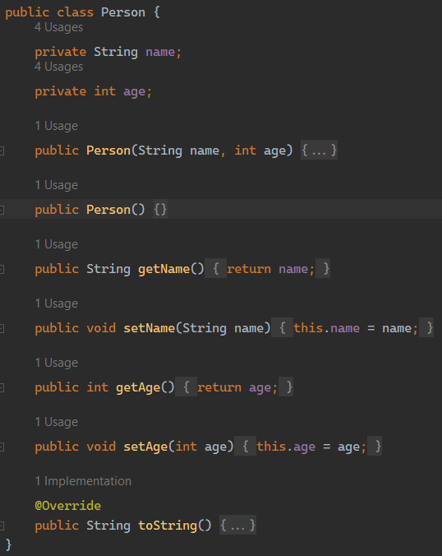

1. What's volatile keyword? Where is it used? Explain pros and cons

Java’s synchronized keyword guarantees both mutual exclusion and visibility. If we make the blocks of threads that modifies the value of shared variable synchronized only one thread can enter the block and changes made by it will be reflected in the main memory. All other thread trying to enter the block at the same time will be blocked and put to sleep.

In some cases, we may only desire the visibility and not atomicity. Use of synchronized in such situation is an overkill and may cause scalability problems. Here volatile comes to the rescue. Volatile variables have the visibility features of synchronized but not the atomicity features. The values of volatile variable will never be cached and all writes and reads will be done to and from the main memory. However, use of volatile is limited to very restricted set of cases as most of the times atomicity is desired. For example, a simple increment statement such as x = x + 1; or x++ seems to be a single operation but is s really a compound read-modify-write sequence of operations that must execute atomically.

1. What's ThreadLocal?

This gives us the ability to store data individually for the current thread – and simply wrap it within a special type of object.

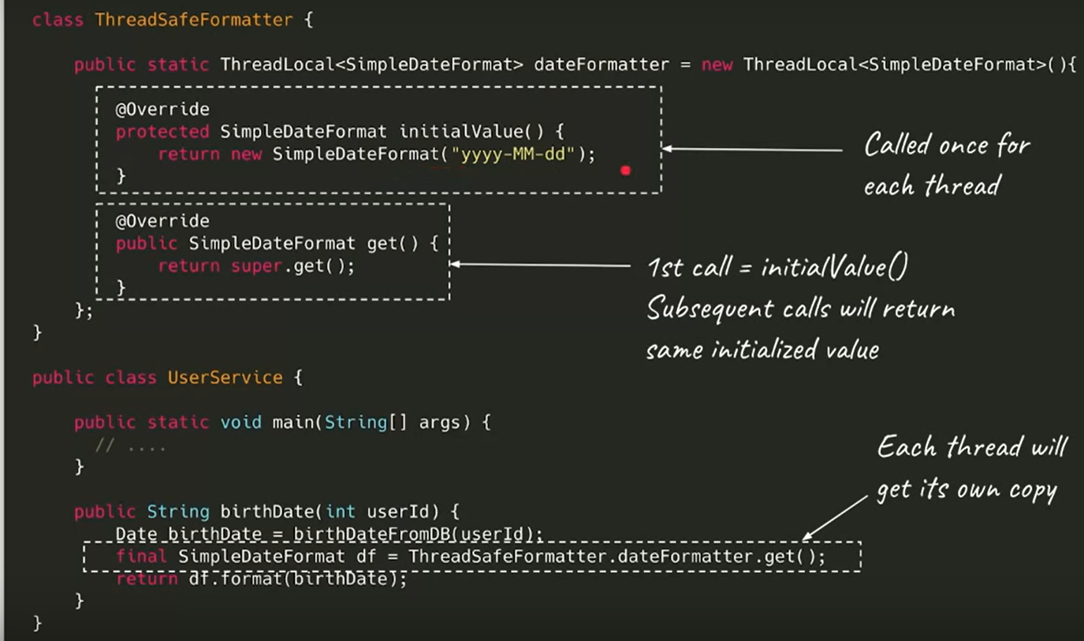

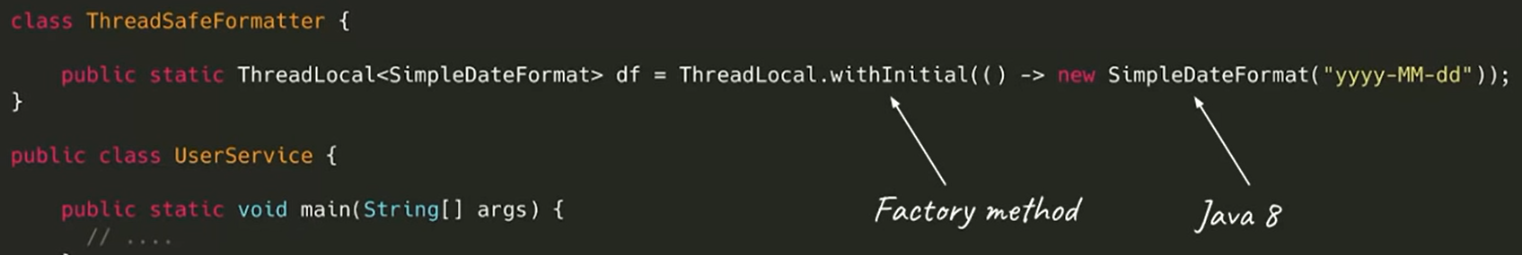

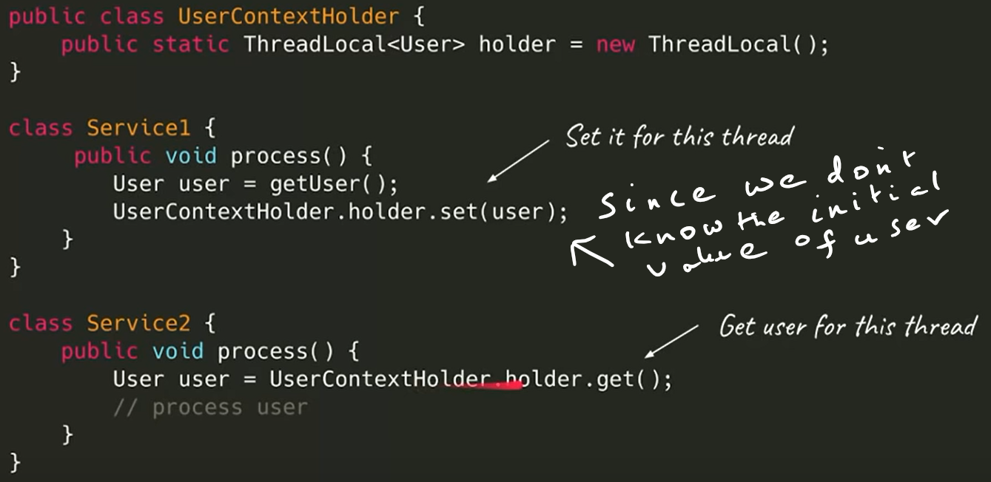

1. How do you lock a resource in Java?
   * Synchronized
   * Lock
   * ReentrantLock – can be worked with Condition
2. What is a semaphore ?

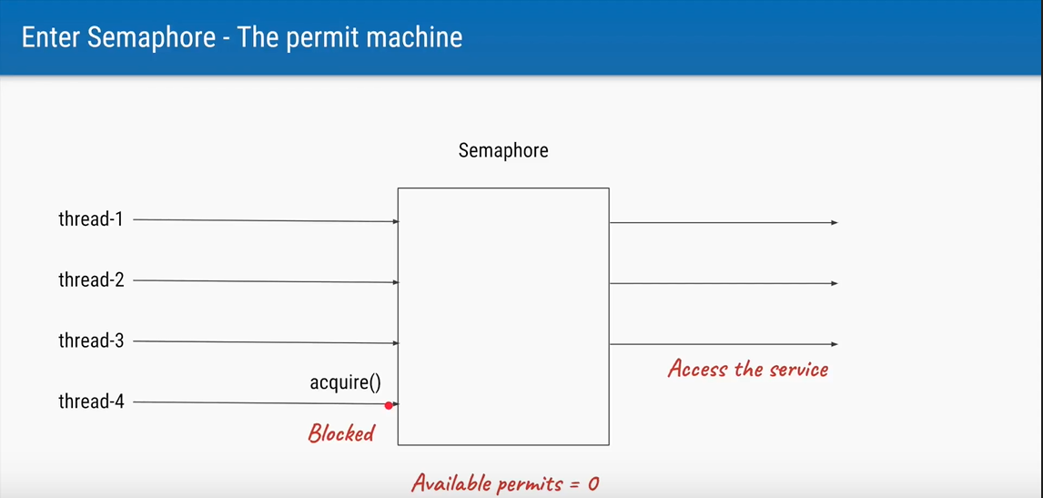

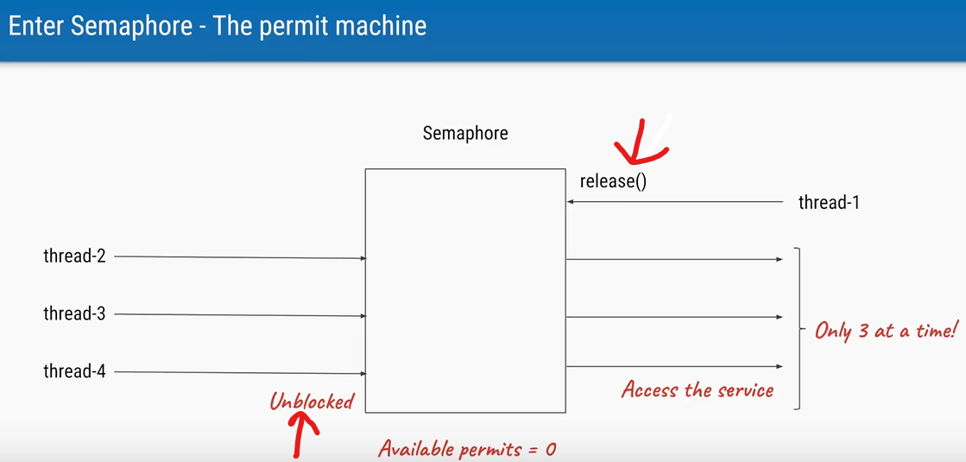

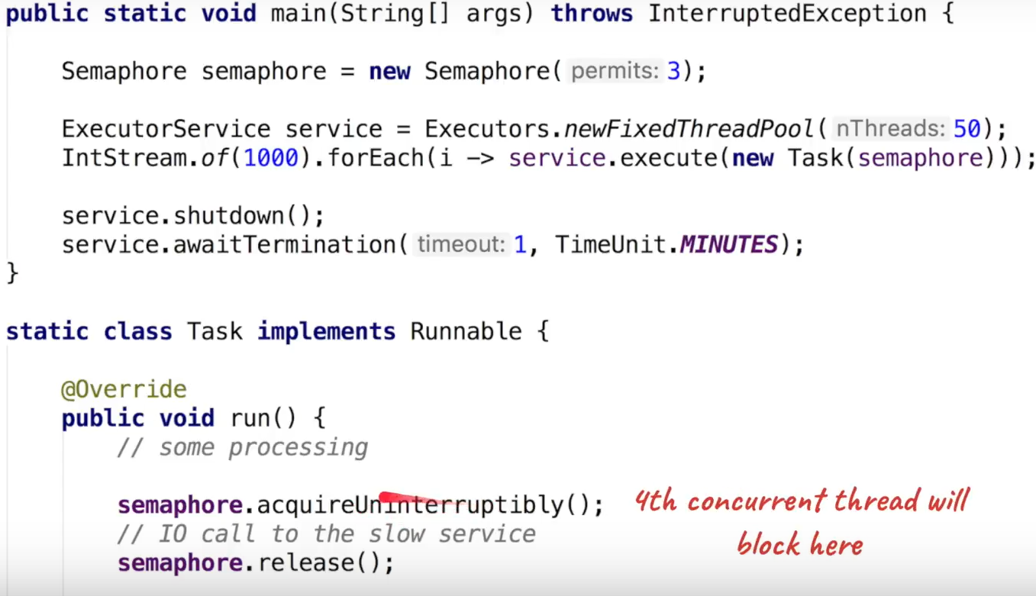

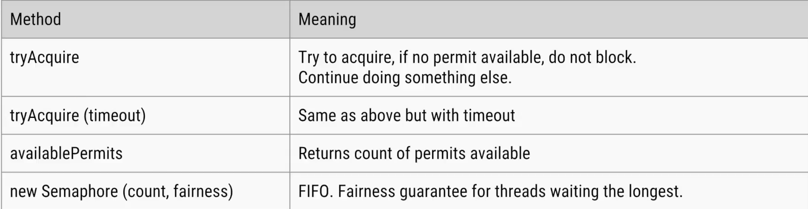

1. What’s an ExecutorService ?

ExecutorService abstracts away many of the complexities associated with the lower-level abstractions like raw Thread. It provides mechanisms for safely starting, closing down, submitting, executing, and blocking on the successful or abrupt termination of tasks (expressed as Runnable or Callable).

Types of schedulers in ExecutorService.

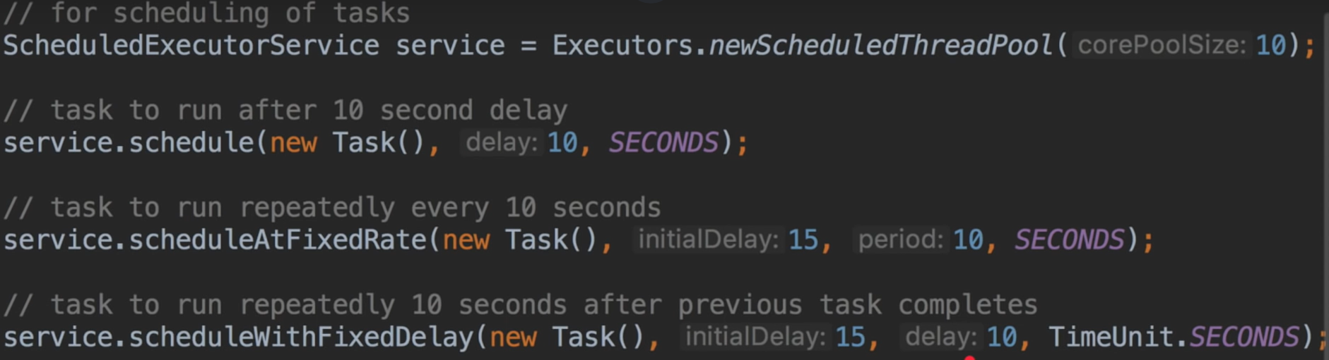

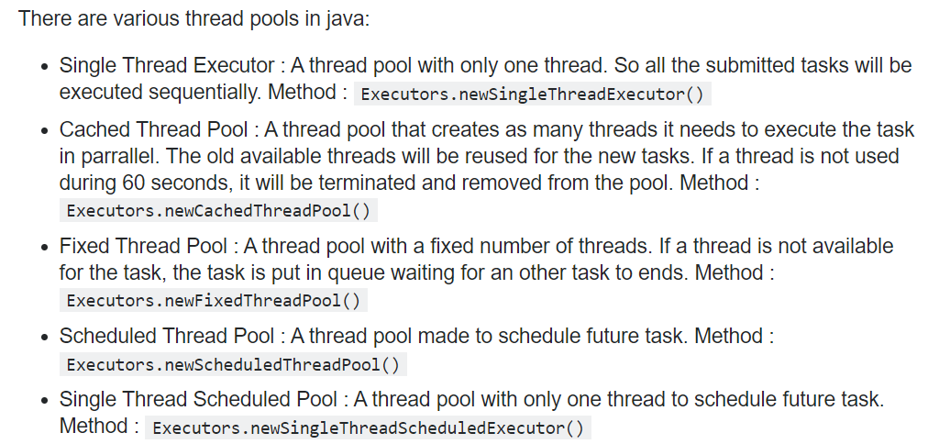

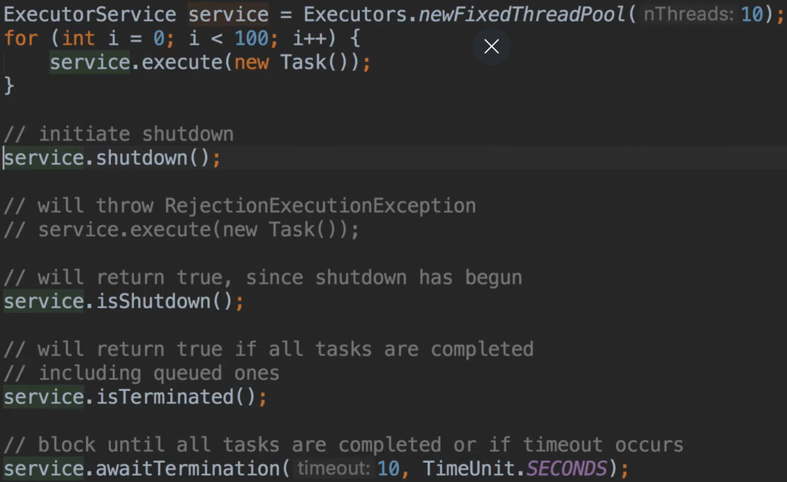

1. What's finally block?

finally block is guaranteed to execute irrespective of the nature of the exit. This includes break, return or exception from the scope of try { } finally.

1. What's finalize?

The **java.lang.Object.finalize()** is called by the garbage collector on an object when garbage collection determines that there are no more references to the object. A subclass overrides the finalize method to dispose of system resources or to perform other cleanup.

Instead of writing finalize() method and calling System.gc() method which is non-deterministic, better to implement AutoCloseable and implement close() method.

public class CloseableResource implements AutoCloseable {

    …………………………………….

    @Override

    public void close() {

        try {

            reader.close();

            System.out.println("Closed BufferedReader in the close method");

        } catch (IOException e) {

            // handle exception

        }

    }

}

public void whenTryWResourcesExits_thenResourceClosed() throws IOException {

    try (CloseableResource resource = new CloseableResource()) {

        String firstLine = resource.readFirstLine();

        assertEquals("baeldung.com", firstLine);

    }

}

1. When is Garbage Collection invoked?

Garbage collection is

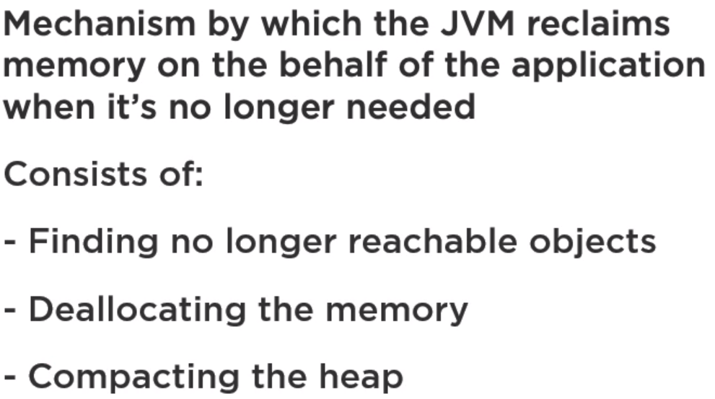

Memory = Amount of memory assigned to the program

Throughput = Time spent running the program vs the GC

Latency = Amount of time spent on GC

Generational Hypothesis:

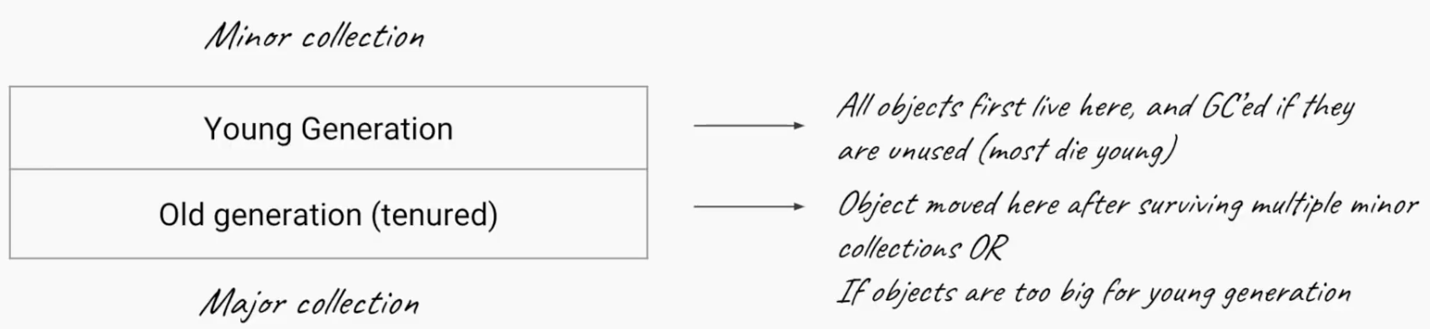

Mark Copy:



Mark Sweep Compact

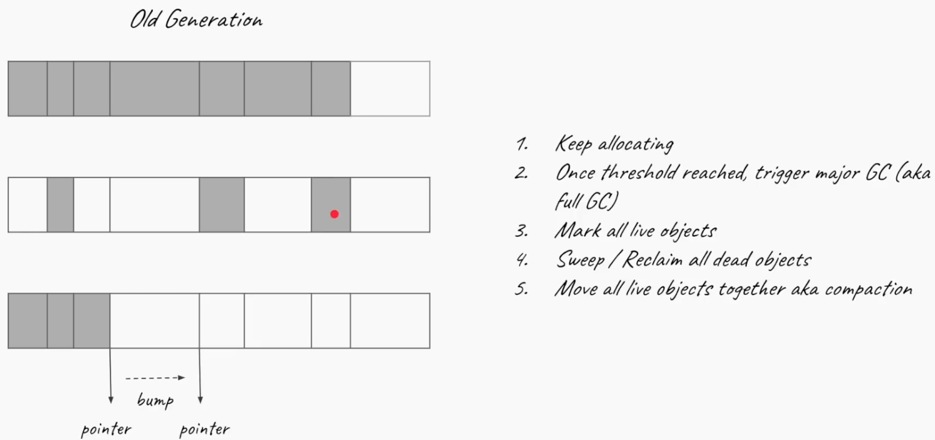

Predictable latency:

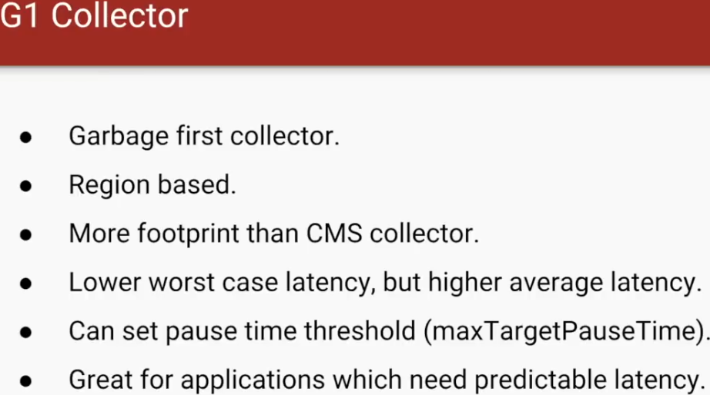

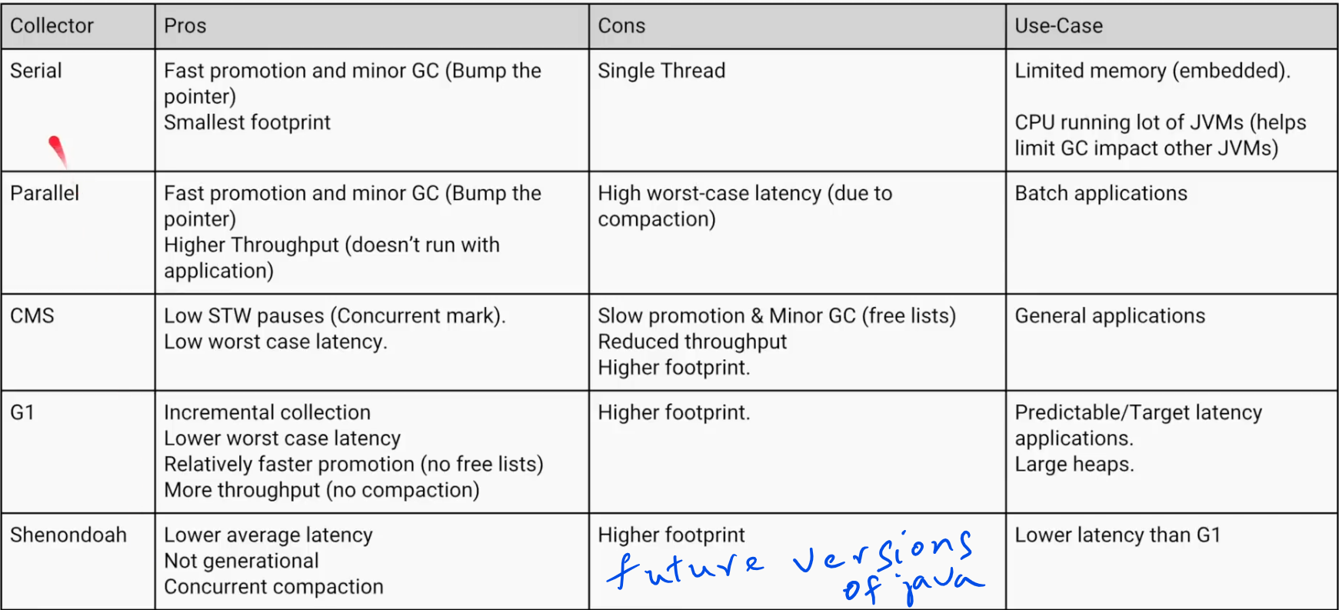

1. How to analyze GC logging?

Manual analysis

gceasy.io (online tool. Not recommended in corporate environments)

1. Troubleshooting memory problems in Java

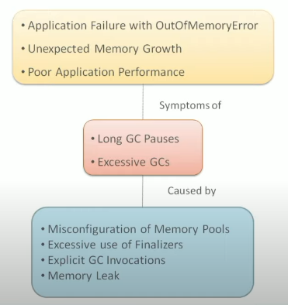

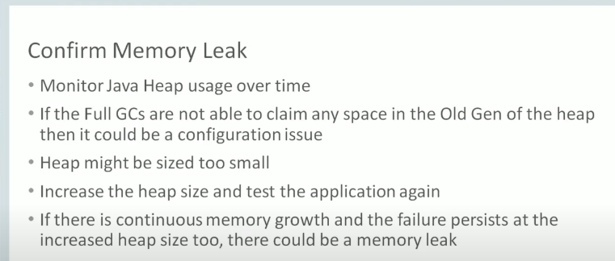

From gc logs, we can collect the heap usage of our applications.

* If we don’t have enough heap memory configured, heap usage keeps increasing. Configure it with -Xmx
* GC logs help us in determining heap requirements
  + Excessive GCs
  + Long GC pauses

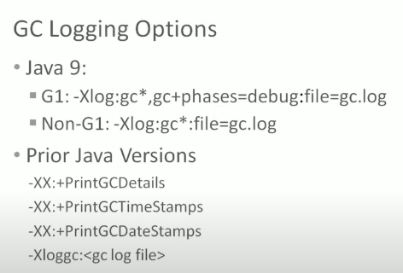

1. What's boxing and unboxing?

Conversion of a primitive type to the corresponding reference type is called boxing, such as an int to a java.lang.Integer. Conversion of the reference type to the corresponding primitive type is called unboxing, such as Byte to byte

1. What problems can arise during unboxing?
   1. Performance problems
   2. NullPointerException
2. What's static class? Why are they needed?

Following are major differences between static nested class and non-static nested class. Non-static nested class is also called Inner Class.

**1)** Nested static class doesn’t need reference of Outer class, but Non-static nested class or Inner class requires Outer class reference.

**2)** Inner class(or non-static nested class) can access both static and non-static members of Outer class. A static class cannot access non-static members of the Outer class. It can access only static members of Outer class.

**3)** An instance of Inner class cannot be created without an instance of outer class and an Inner class can reference data and methods defined in Outer class in which it nests, so we don’t need to pass reference of an object to the constructor of the Inner class. For this reason Inner classes can make program simple and concise.

1. What's java.nio? How are they used in network IO?

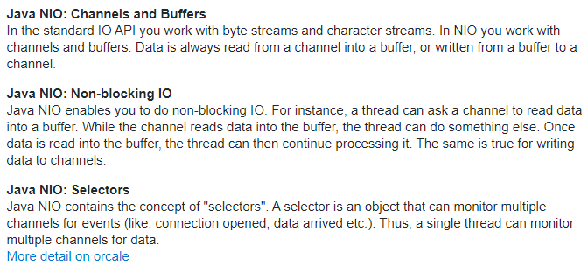

1. What are the different design patterns used in your project?
   * Factory
   * Singleton
   * Builder
   * Visitor
2. What's try with resources?

Automatically closes the resources if the resource is wrapped in a try block. It implements Closable and AutoClosable interfaces.

1. What's a deadlock? How do you prevent it?

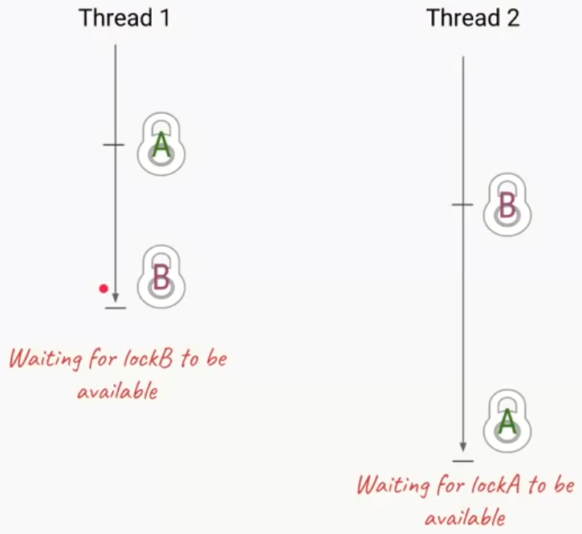

Thread dumps:

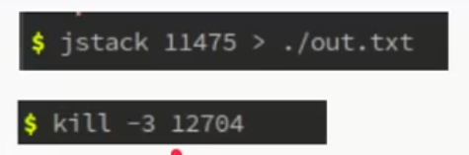

How to prevent ?

1. Using timeout
2. Maintain the ordering of locks.

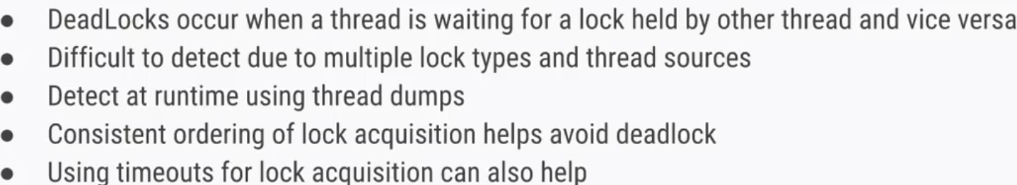

1. What's Thread.wait()?

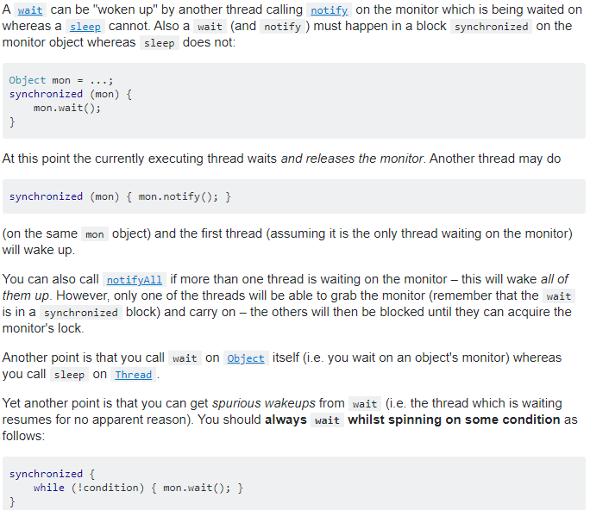

1. Explain Generics.

Generics helps us write generic code with type safety. Without generics the types are resolved as Object type and the code becomes brittle. Generics help us check the types at compile time.

1. Difference between String and StringBuffer?

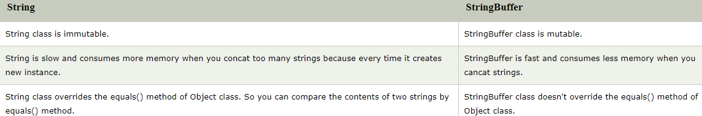

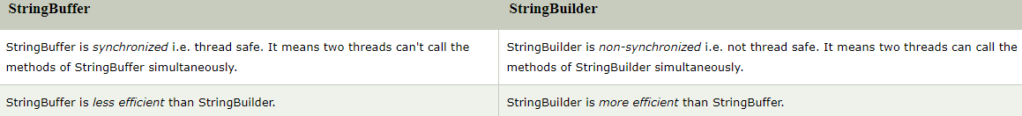

1. What data do threads share?
2. Difference between TreeMap and HashMap

A HashMap works on the principle of hashing.

This Map implementation usually acts as a bucketed hash table, but when buckets get too large, they get transformed into nodes of TreeNodes, each structured similarly to those in java.util.TreeMap.

You can find more on the HashMap's internals in the article focused on it.

On the other hand, TreeMap extends AbstractMap class and implements NavigableMap interface. A TreeMap stores map elements in a Red-Black tree, which is a Self-Balancing Binary Search Tree.

* + *TreeMap* provides a performance of *O(log(n))* for most operations like *add()*, *remove()* and *contains()*
  + A *Treemap* can save memory (in comparison to *HashMap)* because it only uses the amount of memory needed to hold its items, unlike a *HashMap* which uses contiguous region of memory
  + A tree should maintain its balance in order to keep its intended performance, this requires a considerable amount of effort, hence complicates the implementation

We should go for a *TreeMap* whenever:

* + memory limitations have to be taken into consideration
  + we don't know how many items have to be stored in memory
  + we want to extract objects in a natural order
  + if items will be consistently added and removed
  + we're willing to accept *O(log n)* search time

<https://www.journaldev.com/2366/core-java-interview-questions-and-answers#package>

Collections Questions:

**Error! Hyperlink reference not valid.**

1. Producer Consumer implementation

This can be achieved with 2 ways.

1 option is to use a BlockingQueue.

void testProducerConsumerUsingBlockingQueue() throws InterruptedException{  
 BlockingQueue<String> queue = new ArrayBlockingQueue<String>(10);  
  
 final Runnable producer = () -> {  
 int i = 1;  
 while (true) {  
 try {  
 queue.put(String.*format*("Item:%d", i));  
 } catch (InterruptedException e) {  
 e.printStackTrace();  
 }  
 ++i;  
 }  
 };  
  
 new Thread(producer).start();  
  
 final Runnable consumer = () -> {  
 while (true) {  
 try {  
 System.*out*.println(String.*format*("Consuming %s", queue.take()));  
 Thread.*sleep*(1000);  
 } catch (InterruptedException e) {  
 e.printStackTrace();  
 }  
 }  
 };  
  
 new Thread(consumer).start();  
 new Thread(consumer).start();  
  
 Thread.*sleep*(1000 * 60);  
}

2nd option is to create own BlockingQueue.

public class MyBlockingQueue<E> {  
 private Queue<E> queue;  
 private int max = 16;  
 private ReentrantLock lock = new ReentrantLock(true);  
  
 private Condition notFull = lock.newCondition();  
  
 private Condition notEmpty = lock.newCondition();  
 private static final int *timeout* = 1000;  
 private static final TimeUnit *TIME_UNIT* = TimeUnit.*MILLISECONDS*;  
  
 public MyBlockingQueue(int max) {  
 this.queue = new ArrayDeque<>();  
 this.max = max;  
 }  
  
 public void put(E e) throws InterruptedException {  
 if (lock.tryLock(*timeout*, *TIME_UNIT*)) {  
 try {  
 while (queue.size() == max) notFull.await();  
 queue.add(e);  
 System.*out*.println(String.*format*("Added %s", e));  
 notEmpty.signalAll();  
 } finally {  
 lock.unlock();  
 }  
 }  
 }  
  
 public Optional<E> get() throws InterruptedException {  
 if (lock.tryLock(*timeout*, *TIME_UNIT*)) {  
 try {  
 while (queue.isEmpty()) notEmpty.await();  
 Optional<E> result = Optional.*ofNullable*(queue.poll());  
 notFull.signalAll();  
 return result;  
 } finally {  
 lock.unlock();  
 }  
 }  
 return Optional.*empty*();  
 }

public static <E> Runnable getProducer(MyBlockingQueue<E> blockingQueue, Supplier<E> supplier) {  
 return () -> {  
 try {  
 while (true) {  
 blockingQueue.put(supplier.get());  
 Thread.*sleep*(1000);  
 }  
 } catch (InterruptedException ex) {  
 System.*out*.println(ex.getMessage());  
 }  
 };  
 }  
  
 public static <E> Runnable getConsumer(MyBlockingQueue<E> blockingQueue, E defaultValue) {  
 return () -> {  
 while (true) {  
 try {  
 Optional<E> item = blockingQueue.get();  
 System.*out*.println(item.map(e -> String.*format*("Retrieved %s", e))  
 .orElse(defaultValue.toString()));  
 Thread.*sleep*(1000 * 2);  
 } catch (InterruptedException e) {  
 System.*out*.println(e.getMessage());  
 }  
 }  
 };  
 }  
}

MyBlockingQueue<String> blockingQueue = new MyBlockingQueue<>(16);

// Learnt a new thing that we can create class inside lambda and return that class.  
// This way we would not be polluting the global namespace  
// with classes that otherwise don't make sense to be standalone.

Supplier<Supplier<String>> stringSupplier = () -> {  
 class StringSupplier implements Supplier<String> {  
 int i = 0;  
 @Override  
 public String get() {  
 ++i;  
 return String.*format*("Item: %d", i);  
 }  
 }  
 return new StringSupplier();  
};  
  
  
Runnable producer = MyBlockingQueue.<String>*getProducer*(blockingQueue, stringSupplier.get());  
Runnable consumer = MyBlockingQueue.<String>*getConsumer*(blockingQueue,"Not Item found");  
  
new Thread(producer).start();  
new Thread(consumer).start();  
new Thread(consumer).start();  
  
Thread.*sleep*(1000 * 60);

1. What is ReentrantLock ?

It allows us to call the lock on the same lock object multiple times before unlock is called.

For e.g., if there is any need to call in a recursive method, then lock on the lock object is called multiple times before unlock is called.

In such cases, ReentrantLock is useful. The point to remember is to call unlock on the lock the same number of times the lock is called. getHeldCount() gives the number of locks that got acquired by the lock.

|  |  |  |
| --- | --- | --- |
|  | Advantage | Disadvantage |
| Fair Lock | Equal chance for all threads | Slower |
| Unfair Lock | Faster (more throughput) | Possible thread starvation |

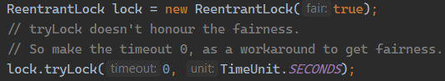

1. Scatter and Gather pattern.

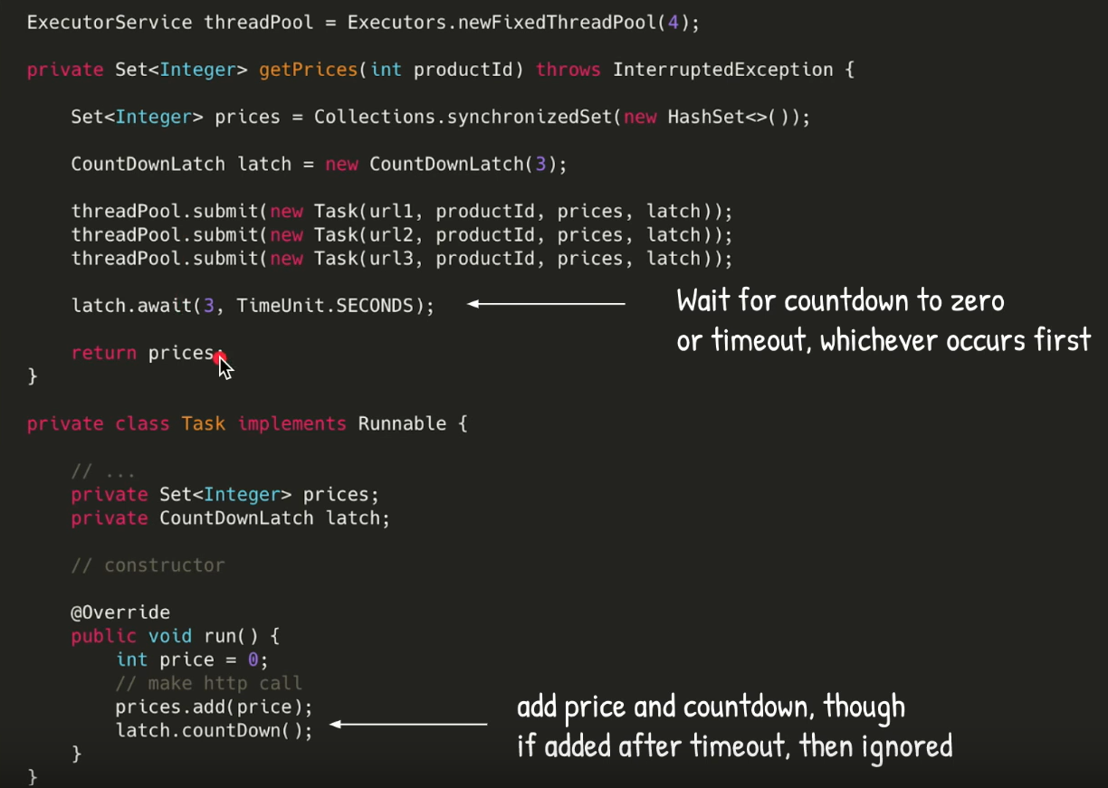

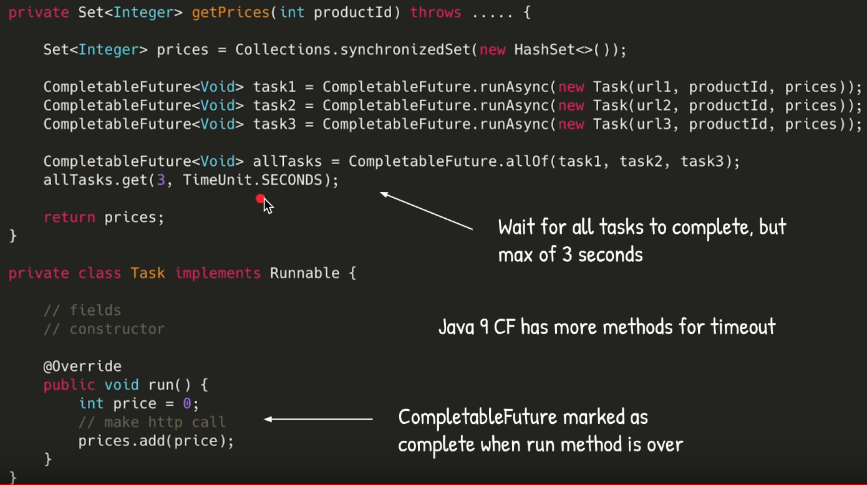

1. What are various code optimization techniques?

* Ensure appropriate garbage collector is configured for the application
* Design classes such that objects are of optimal size.
* Ensure objects are not long lived thereby causing the application to consume more memory
* Choosing right data structures
* Lazy initialization
* Concurrency is used to improve the latency of the application
* Connection pooling
* Statement caching – Compiled Pattern matching for example.
* Batching – sending multiple queries instead of 1 at a time or just using stored procedures.
* When trying to scale up the services, we can microservices but that comes with a disadvantage of performance overhead of intercommunication overhead.

To reduce intercommunication overhead, we can use binary format (e.g. Protobuf, Thrift, Avro, MessagePack)

* Asynchronous communication.

1. C++ Templates vs Java Generics

|  |  |
| --- | --- |
| C++ Templates | Java Generics |
| Allows primitive types, functions, literally any type can be a template type. | Allows only classes. |
| The type is compiled into new class. If the number of copies of the class is directly proportional to the number of template types used for the class. | Uses type erasure to erase the type and replace with casts and Object class.  Generics is only for compile time type checking. |

Java Generics:

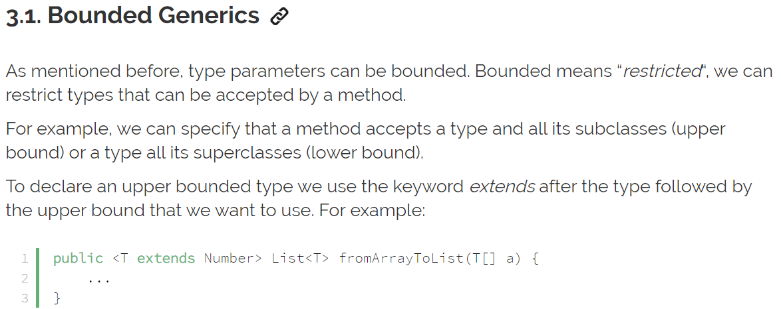

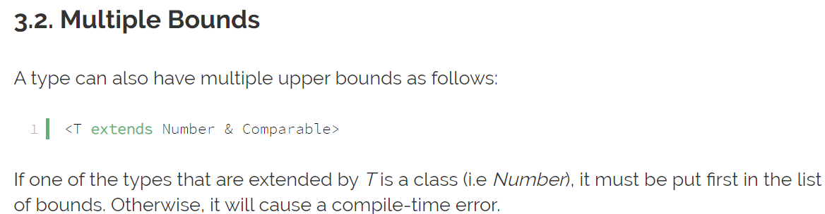

<https://github.com/eugenp/tutorials/tree/master/core-java-modules>

1. Runnable vs Callable

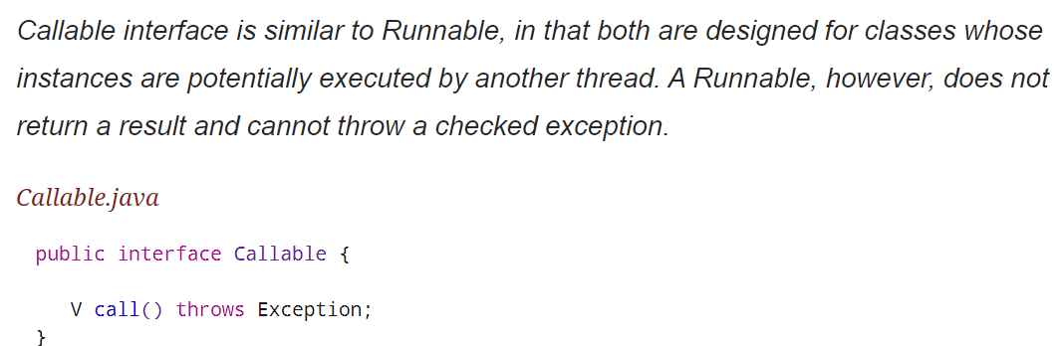

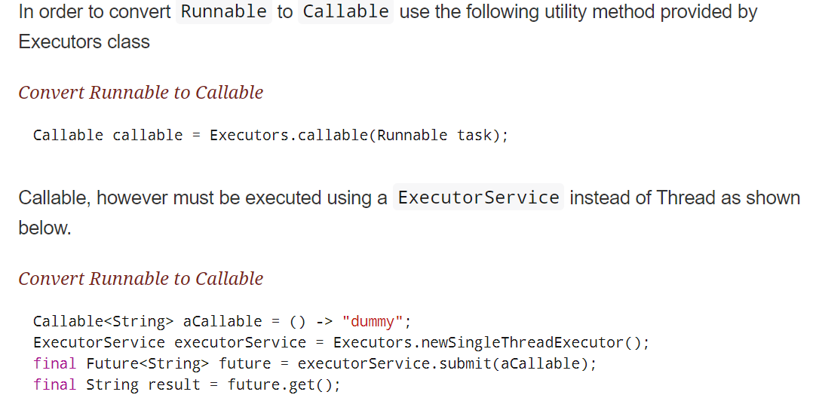

**Microservices**

* Service Registry: Every microservice should update the registry of all the services that are created.

Service Registry / Service Discovery

Distributed Microservice

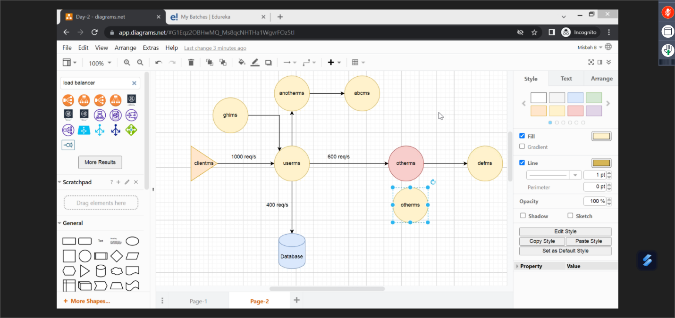

If the Data Centre is not available, then the services can go down and there can be disruption.

This can be solved by Circuit Breaker architecture.

**Circuit Breaker**

It is used to keep the stack more resilient.

**API Gateway**

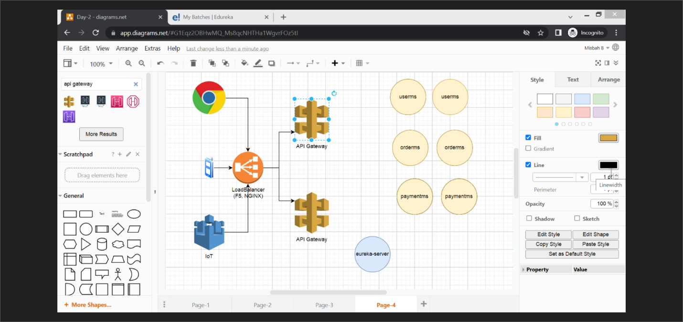

We need load-balancer for API Gateway.

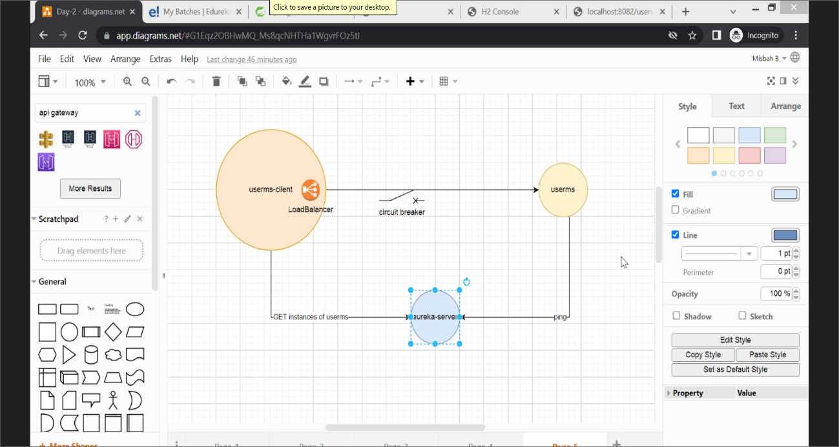

**Database strategies**

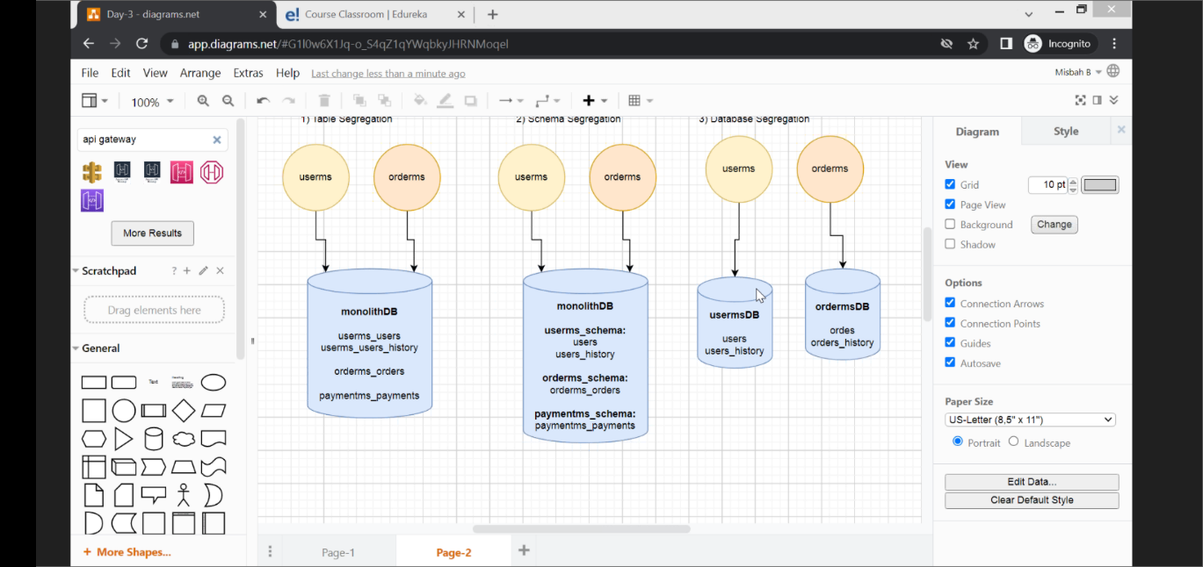

**Messaging**

